CEN and/or CLC Workshop ‘insert title’

Workshop description form
- PART A – Workshop Summary
- PART B – Project Plan

PART A – Workshop SUMMARY
1 | WS details
 | Organization |  | CEN  CENELEC  Joint with | CEN lead | CENELEC lead
 | Title | CEN/CLC WS ‘’  (select CEN or CLC or leave CEN/CLC in case of joint WS)
 | Scope | Type here
 | Does this WS stem from an EU Research project? |  | YES  Name of the project: Type here  Grant number: Type here  End date Type here  NO
 | Financial support |  | EU Research project  EC/EFTA Grant reference: Type here  Other Specify, if needed: Type here
 | WS Proposer/Proposed Chair WS proposer | Name:  Organization:  Postal address:  Email:  Phone:  Webpage:  Contact person (name and email): |  | Type here  Type here  Type here  Type here  Type here  Type here  Type here
 | WS Secretariat | Organization:  Postal address:  Email:  Phone:  Webpage:  WS Secretary name:  Email:  Phone: |  | Type here  Type here  Type here  Type here  Type here  Type here  Type here  Type here
 | CEN and CENELEC Management Centre (CCMC) contact | Organization:  Postal address:  Webpage:  CCMC Project Manager name:  Email:  Phone: |  | CEN and CENELEC  Rue de la Science 23B - 1040 Brussels, Belgium  https://www.cencenelec.eu/Pages/default.aspx  Type here  Type here  Type here
 | Tentative date and place of the Kick-off Meeting | Date: Type here |  | Place: Type here
 | Does the proposed Workshop fall within the scope of existing CEN and/or CENELEC Technical Bodies? |  |  | YES  Specify: Type here  NO
 | Are there other Technical Bodies or Joint Advisory and Coordination Groups potentially interested in the Workshop? ? |  | YES  Specify: Type here  NO
 | Are the following aspects affected? | Safety matters  Management system aspects  Conformity assessment aspects  Security matters |  | YES  YES  YES  YES |  | NO  NO  NO  NO
Add information/explanations if Management System aspects and Conformity Assessment aspects are affected:
Type here

2 | WS Deliverables
 | CWA #1
 | Title |  | Same as WS title (1.2)  Other: Type here
2.1.2 | Scope |  | Type here
2.1.3 | Does the proposed CWA conflict with a published EN |  | YES  Specify: Type here  NO  In case the answer is ‘yes’, the development of the CWA shall be stopped

PART B – Project Plan
Foreword (TO BE DELETED BEFORE THE PUBLICATION OF THE DRAFT PROJECT PLAN)
The content of the project plan is structured into chapters. These chapters represent the Workshop project plan’s minimum content, as well as optional but recommended text modules. There is no restriction on the addition of further chapters if this is deemed useful.
Colour code:
- Black/regular text: Fixed text modules. Please do not change.
- Green/underlined text: Optional but recommended text modules. Please adjust according to your needs.
- <Red/bold text>: Placeholder. Please fill in.
- Blue/italic text: Explanation. Please delete in the final version.
Abstract
The project plan is intended to help the Workshop proposer reflect on how to disseminate and involve a wider range of interested parties throughout the lifetime of the Workshop. It is recommended to include a short abstract indicating the context in which the CWA(s) is/are developed, e.g. Why is this Workshop initiated? What is the need for this Workshop? Which issue(s) should be solved by the Workshop? What is the future benefit of the CWA(s)? What is explicitly not part of the CWA(s)? The abstract can be used for public relations to provide a short description of the Workshop.

Status of the project plan
The project plan serves to inform the public of the new Workshop and to lay down the Workshop’s framework conditions. Because the project plan has to be modified and updated throughout the initiation and development of the CWA(s), the status shall be indicated each time a modification is made, and each version shall be given a version number, as follows. Depending on the Workshop's status, delete either the status Draft project plan or the status Approved project plan:
Draft project plan for public commenting (Version 1.0)
This draft project plan is intended to inform the public of a new Workshop. Any interested party can take part in this Workshop and/or comment on this draft project plan by sending an email to the WS secretary.
All those who have applied for participation or have commented on the project plan by the deadline will be invited to the kick-off meeting of the Workshop on <yyyy-mm-dd>.
Approved project plan for CWA development adopted at the kick-off meeting of the Workshop on <yyyy-mm--dd> (Version <No.>)

Workshop proposer and potential Workshop participants
The information that is provided in this chapter depends on the purpose of the project plan. In case of a proposal for a new Workshop, it is necessary to mention a contact point from the proposer's side. Similar information applies to further milestones in the Workshop's lifetime: Who approved the creation of the Workshop at the kick-off meeting?
The following information is therefore requested (depending on the Workshop's status, grey out as appropriate):
- Workshop proposer (contact details are provided in Part A of this form)
- Potential participants

Workshop proposer
Information on the Workshop proposer and their background, including the name and a short description of their organization is to be given here. The contact details are given in Part A of this form.
Person (and organization) 1:
Short description and interest in the subject:
Person (and organization) 2:
Short description and interest in the subject:
etc.

Potential participants
Actors who could be interested in and/or should be asked to participate in the Workshop should be listed here. Potential participants may be persons or organizations expressly named, or generally described (Industry and commerce, Government, Consumer, Labour, Academic and research, Standards application, Non-governmental organization (NGOs) or more specific "manufacturers of ...", "test institutes for ...", "representatives of the public sector", "research institutes for ...", "system providers", etc.).
This CWA will be developed in a Workshop (temporary body) that is open to any interested party. The participation of the following persons/organizations would be helpful and is desired. It is recommended that:
- category of potential participants A
- category of potential participants B
- category of potential participants C
- category of potential participants D
- etc.
take part in the development of this CWA.

Workshop objectives and scope
This section should contain a broad statement of the overall goal of the Workshop, including the justification for the specific CWAs if there are more than one. It may mention the origin of the proposed activities, where this is important to provide the context of the proposal. This section should include stable information, valid for the lifetime of the Workshop. The presence of detailed timescales in this part of the document should be avoided.

Workshop background
This section explains why the Workshop should be initiated and describes the current issues and future added value of the document (need for standardization). This section should include information about:
- Motivation for the creation of this Workshop: e.g. Why is this Workshop initiated? What is the need for this Workshop? Which issue(s) should be solved by the Workshop? What is the future benefit of the CWA(s)? What is explicitly not part of the CWA(s)?.
- Market environment (e.g. What is already on the market and how does the envisaged CWA(s) differ from it?)
- Does the WS stem from a European Project (e.g. Horizon 2020, Horizon Europe)?
- Is the WS funded by EC/EFTA?
- Legal environment (Directives and relevant European legislation)
- This section shall include information about existing standards and standard related activities and documents. This section shall specify any requirements for liaison with CEN or CENELEC Technical Committees or other bodies or organizations.

Workshop programme

General
This chapter gives information on the date of the kick-off meeting and the planned number of additional meetings and/or web conferences.
In addition, information is provided on whether the publication of a/the draft CWA(s) is planned (this must then also be included in the calculation) and the language in which the CWA(s) and, if applicable, the (optional) draft are to be written. The CWA(s) shall be drafted and published in English. If drafting and publication in an additional language is required, the project plan shall mention it.
The kick-off meeting is planned to take place on <date> in <place/link as virtual/hybrid meeting>. A draft for public commenting will <not> be published for <duration> days.
A total of <number of agreed meetings> Workshop meetings (kick-off meeting and Workshop meetings) and web conferences will be held, during which the content of the CWA(s) will be presented, discussed and approved.
The working language (language of meetings, minutes, etc.) of the WS will be <language>. The CWA will be written in <language>.

Workshop schedule
This section should list the specific work items with their deliverable and timeframe for delivery (see Table 1).
The timeframe for the development of work items stated in the project plan at the time of its adoption must remain visible in later versions/revisions of the project plan.
Where it is intended to develop a CWA in more than one part, each part must be listed separately as a work item. Where the Workshop is developing several work items, it is recommended that the work programme is limited in this chapter to a bulleted list of the work items with links to an annex where a more detailed explanation of the work items is provided.

The following project schedule is for orientation only and is to be modified as the Workshop progresses. The amount and the duration of the various Workshop phases are particularly dependent on the requirements and wishes of the Workshop proposer.
Table 1: Workshop schedule (preliminary)

CEN/CENELEC Workshop | M01 |  |  |  | M02 |  |  |  | M03 |  |  |  | M04 |  |  |  | M05 |  |  |  | M06 |  |  |  | M07 |  |  |  | M08 |  |  |  | M09 |  |  |  | M10 |  |  |  | M11 |  |  |  | M12 |  |  |  | …
Initiation
1. Workshop description form submission and TC response
2. Open commenting period on draft project plan (mandatory)
Operation
3. Kick-off meeting
4. CWA(s) development
5. Open commenting period on draft CWA(s) (optional)
6. CWA(s) finalized and approved by Workshop participants
Publication
7. CWA(s) publication
Dissemination (see 6)
Milestones |  |  |  |  |  |  |  |  |  |  | K |  |  |  | V |  |  |  | V |  |  |  | M |  |  |  | V |  |  |  |  |  |  |  |  |  |  |  |  |  | M/A |  |  |  |  |  | P | D

Legend
K Kick-off
M Workshop meeting
V Virtual Workshop meeting
A Adoption of CWA
P Publication of CWA
D Online distribution of CWA

Work already delivered by the Workshop
This section has to be completed only in case the Workshop has been operational for some time. CWAs already produced are to be listed.

Resource planning
All costs related to the participation of interested parties in the Workshop’s activities have to be borne by themselves. This principle should be stated in the project plan.
In case there is a fee for registered participation in the Workshop (as part of the Workshop’s funding process), this fee has to be explained in this section.
In the resource section, details can be given on the parts of the Workshop’s operation for which EC/EFTA funding is required, as well as the amount of this funding. In case of Project Teams (or paid editors in case of one-person Project Teams) that require EC/EFTA funding, there is a requirement to specify the number of expert person-days that require funding.
- Option 1: The Workshop participants finance the Workshop themselves.
- Option 2: The Workshop proposer finances the Workshop.
- Option 3: The Workshop will be financed within the framework of a research project.

Workshop structure and rules of cooperation
This chapter lists the prerequisites for Workshop participation, as well the organization of the Workshop participants' joint work. The Workshop structure and the responsibilities of the main actors (e.g. Workshop Chair, Workshop Vice Chair, Workshop secretariat, Workshop participants, etc.) are to be described as well as a decision-making process.

Participation in the Workshop
The Workshop will be constituted during the kick-off meeting. By approving this project plan, the interested parties declare their willingness to participate in the Workshop and will be formally named as Workshop participants, with the associated rights and duties. Participants at the kick-off meeting who do not approve the project plan are not given the status of a Workshop participant and are thus excluded from further decisions made during the kick-off meeting and from any other decisions regarding the Workshop.
As a rule, the request to participate in the Workshop is closed once it is constituted. The current Workshop participants shall decide whether any additional members will be accepted or not.
Any new participant in the Workshop at a later date is decided on by the participants making up the Workshop at that time. It is particularly important to consider these aspects:
- expansion would be conducive to shortening the duration of the Workshop or to avoiding or averting an impending delay in the planned duration of the Workshop;
- the expansion would not result in the Workshop taking longer to complete;
- the new Workshop participant would not address any new or complementary issues beyond the scope defined and approved in the project plan;
- the new Workshop participant would bring complementary expertise into the Workshop in order to incorporate the latest scientific findings and state-of-the-art knowledge;
- the new Workshop participant would actively participate in the drafting of the manuscript by submitting concrete, not abstract, proposals and contributions;
- the new Workshop participant would ensure wider application of the CWA.
All Workshop participants who approved the publication of the CWA or its draft will be named as authors in the European Foreword, including the organizations which they represent. All Workshop participants who did not approve the publication of the CWA will not be named in the European Foreword.

Workshop responsibilities
The Workshop Chair is responsible for content management and consensus building. The Workshop Chair is supported by the Workshop Vice-Chair (if any) and the responsible Workshop secretariat, whereby the Workshop secretariat will always remain neutral regarding the content of the CWA(s). Furthermore, the Workshop secretariat shall ensure that CEN-CENELEC's rules of procedure, rules of presentation, and the principles governing the publication of CWA(s) have been observed. Should a Workshop Chair no longer be able to carry out her/his duties, the Workshop secretariat shall initiate the election of a new Workshop Chair. The list below covers the main tasks of the Workshop Chair. It is not intended to be exhaustive.
- Content related contact point for the Workshop
- Presides at Workshop meetings
- Ensures that the development of the CWA respects the principles and content of the adopted project plan
- Manages the consensus building process, assesses when the Workshop participants have reached agreement on the final CWA, on the basis of the comments received
- Ensures due information exchange with the Workshop secretariat
- Represents the Workshop and its results to exterior
The Workshop secretariat, provided by a CEN and/or CENELEC Member, is responsible for organizing and leading the kick-off meeting, in consultation with the Workshop proposer. Further Workshop meetings and/or web conferences shall be organized by the Workshop secretariat in consultation with the Workshop Chair. The list below covers the main tasks of the Workshop secretariat. It is not intended to be exhaustive.
- Administrative and organizational contact point for the Workshop
- Ensures that the development of the CWA respects the principles and content of the adopted project plan and of the requirements of the CEN-CENELEC Guide 29
- Formally registers Workshop participants and maintains record of participating organizations and individuals
- Offers infrastructure and manages documents and their distribution through an electronic platform
- Prepares agenda and distributes information on meetings and meeting minutes as well as follow-up actions of the Workshop
- Initiates and manages CWA approval process upon decision by the Workshop Chair
- Interfaces with CEN-CENELEC Management Centre (CCMC) and Workshop Chair regarding strategic directions, problems arising, and external relationships
- Advises on CEN-CENELEC rules and brings any major problems encountered (if any) in the development of the CWA to the attention of CEN-CENELEC Management Centre (CCMC)
- Administrates the connection with relevant CEN or CENELEC/TCs

Decision making process
The CEN and/or CENELEC Workshop Chair is responsible for ensuring that the development of the CWA follows the principles and content of the project plan described in this document and the requirements of CEN-CENELEC Guide 29. The CEN and/or CENELEC Workshop Chair may take decisions on the conduct of the CEN and/or CENELEC Workshop on the basis of the comments expressed by the participants and of CEN-CENELEC Guide 29.
Decisions shall be taken based on consensus of the WS participants.

Dissemination and participation strategy
The project plan is intended to help the Workshop proposer reflect on how to disseminate and involve a wider range of interested parties throughout the development of the CWA and after its publication. It is recommended to include a strategy defining how and when participants, other standardization bodies and other stakeholders can be informed of the work and contribute to it.
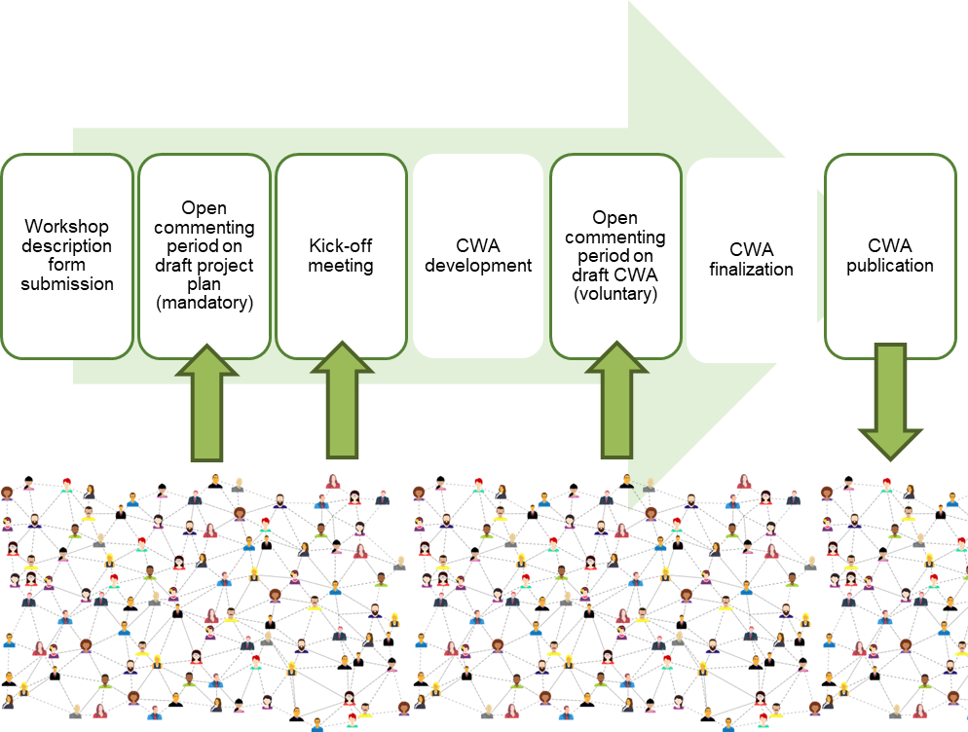

Potential participants identified in section 2.2 and potential interested stakeholders identified in Part A should be informed of the open commenting phase, if any, and of the publication of the CWA.
In addition to the CCMC website, the final CWA might be advertised on:
- sector specific newsletter
- social media, such as
  - Facebook
  - Instagram
  - LinkedIn
  - X
- Research Gate
- EC Newsroom
- Others

Annex I – Security risk analysis

This annex shall be completed if section 1.12 of Part A indicates that security aspects are addressed by the Workshop.
I.I General
Security risk analysis is a process of identifying and analyzing the main negative factors that may affect a standardization project’s objectives. The following is targeted at secretariats of CEN and/or CENELEC Workshop Agreements (CWA) dealing with security issues. Its purpose is to help them identify and mitigate the risks associated with their project. It is structured around two main security threats that can affect the success of the work: major diverging interests among stakeholders and sensitive information.
I.II Risk analysis on major diverging interest among stakeholders
Diverging interests among stakeholders can impede the process in reaching agreement on the CWA and even lead to failure to deliver the planned CWA. In order to identify and possibly mitigate the risks, the following questions should be reviewed:
- Is the planned CWA expected to have a major impact on the security policy/strategy of the core stakeholders?
- Does the scope of the CWA cover products or services with a clear dual-use purpose (i.e. which can be used for military purposes)?
I.III Risk analysis on sensitive information
- In light of the scope of the CWA, is it likely that it may deal with sensitive information? If so, what is the information sensitivity level?
- Is there a need for a (non-)disclosure agreement?
- Is there any conflict of interest for stakeholders involved in the CEN and/or CENELEC Workshop, regarding especially the use they may make of any information they receive during the development of the CWA?
- What steps should be taken to manage information dissemination and storage (e.g. memory stick, emailing, storage) during the development process of the CWA?

Part A and Part B of this form shall be sent by the WS secretary to the secretary of the Technical Bodies identified in this section to inform them about the creation of the WS and register any possible objection within 30 days (45 during the holiday period).
Part A and Part B of this form should be sent by the WS secretary to the Bodies identified in this section to inform them about the creation of the WS.
Work on the proposed CEN and/or CENELEC Workshop shall not be initiated.
The CEN and/or CENELEC Workshop proposal shall be submitted to the CEN/CENELEC BT(s) for decision.
CEN-CENELEC Internal Regulations - Part 3, Clause 33 applies.
For projects dealing with security matters the security risk analysis provided in Annex I shall be carried out.
See Note 2 in CEN-CENELEC Guide 29, Clause 3.
See Note 2 in CEN-CENELEC Guide 29, Clause 3.

